**Launch Template**

**Step 1 – Go to Lunch templates—fill name of template, Select AMI image (MY AMI)—fill required info launch.**

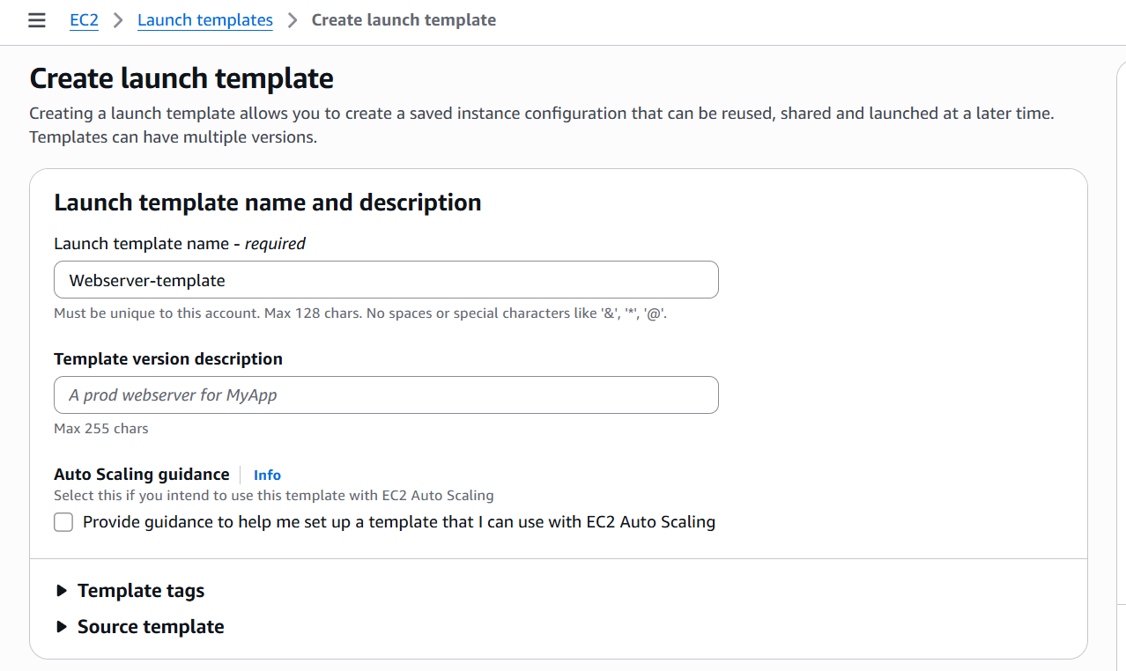

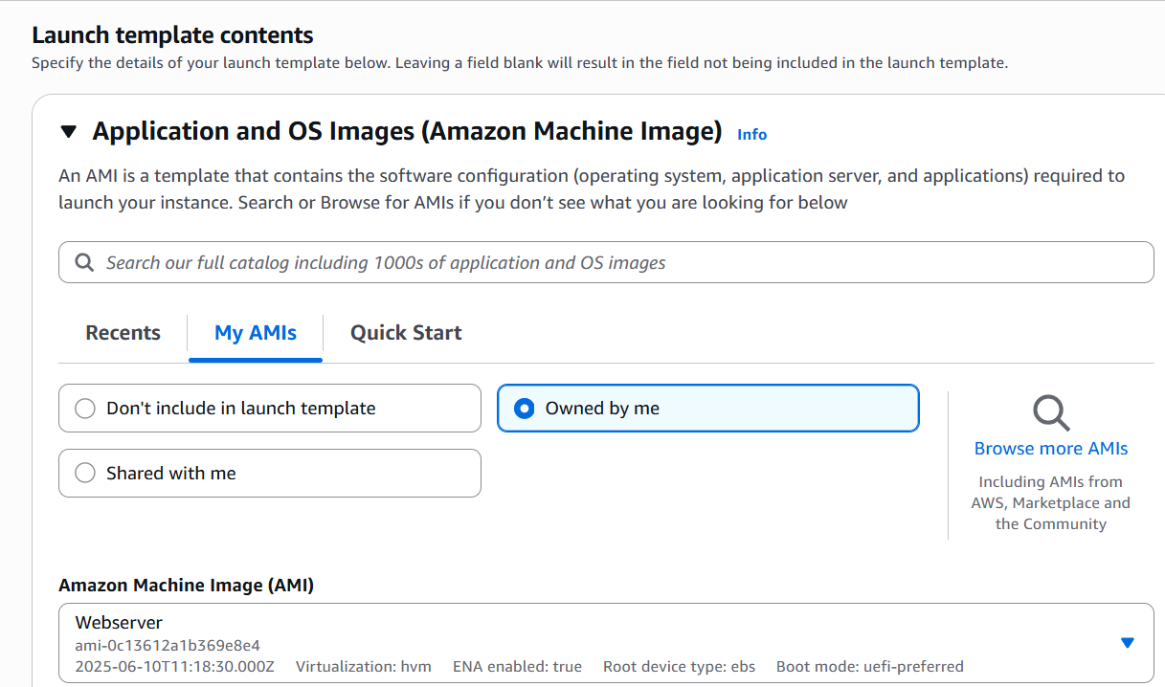

Step 2 – Once template launch now we will create instance from that template

Action—launch instance from template—create.

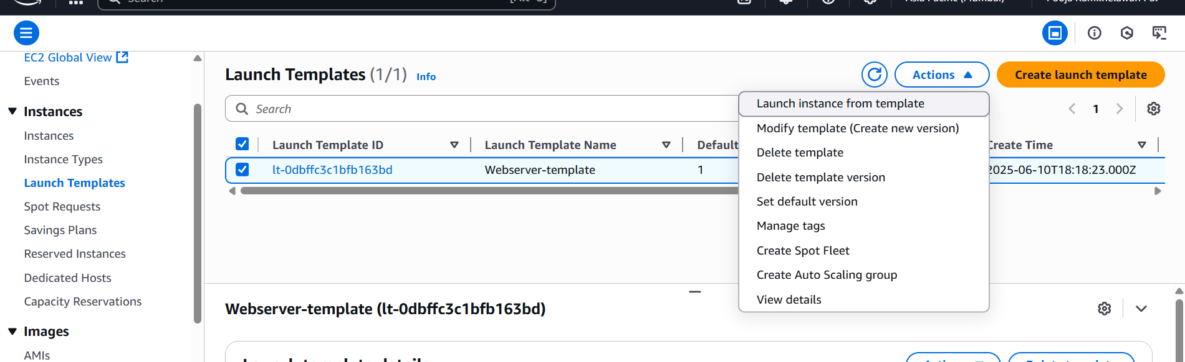

Step 3 – Instance created from template successfully.

